Task 3: Using Clauses, Operators and Functions in queries Perform the query processing on databases for different retrieval results of queries using DML, DRL operations using aggregate, date, string, indent functions, set clauses and operators.
SQL Aggregate Functions
- MIN() - returns the smallest value within the selected column
- MAX() - returns the largest value within the selected column
- COUNT() - returns the number of rows in a set
- SUM() - returns the total sum of a numerical column
- AVG() - returns the average value of a numerical column
Step 1:
Execute the below statement to create an employee table:
CREATE TABLE employee(
name varchar(45) NOT NULL,
occupation varchar(35) NOT NULL,
working_date date,
working_hours varchar(10)
);
Step 2 : Execute the below statement to insert the records
INSERT INTO employee VALUES
('Robin', 'Scientist', '2020-10-04', 12),
('Warner', 'Engineer', '2020-10-04', 10), ('Peter', 'Actor', '2020-10-04', 13), ('Marco', 'Doctor', '2020-10-04', 14), ('Brayden', 'Teacher', '2020-10-04', 12), ('Antonio', 'Business', '2020-10-04', 11);
1. Count() Function
SELECT COUNT(name) FROM employee;
2. Sum() Function
SELECT SUM(working_hours) AS "Total working hours" FROM employee;
3. AVG() Function
SELECT AVG(working_hours) AS "Average working hours" FROM employee;
4. MIN() Function
SELECT MIN(working_hours) AS Minimum_working_hours FROM employee;
5. MAX() Function

SELECT MAX(working_hours) AS Maximum_working_hours FROM employee;
6. FIRST() Function
SELECT working_date FROM employee LIMIT 1;
SQL Date and Time Functions
1. NOW()
Returns the current date and time.
Query:
SELECT NOW();
2. CURDATE()
Returns the current date.
Query:
SELECT CURDATE();
3. CURTIME()
Returns the current time.
Query:
SELECT CURTIME();
4. DATE()
Query:
SELECT Name, DATE(BirthTime) AS BirthDate FROM Test;
5. EXTRACT()
Query1:
SELECT Name, Extract(DAY FROM BirthTime) AS BirthDay FROM Test;
Query2:
SELECT Name, Extract(YEAR FROM BirthTime) AS BirthYear FROM Test;
Query3:
SELECT Name, Extract(SECOND FROM BirthTime) AS BirthSecond FROM Test;
6. DATE_ADD()
Query 1:
SELECT Name, DATE_ADD(BirthTime, INTERVAL 1 YEAR) AS BirthTimeModified FROM Test;

Query 2:
SELECT Name, DATE_ADD(BirthTime, INTERVAL 30 DAY) AS BirthDayModified FROM Test;
7. DATEDIFF()
SELECT DATEDIFF(month,'2017-01-13','2017-01-03') AS DateDiff

SQL OPERATORS
SQL OPERATORS

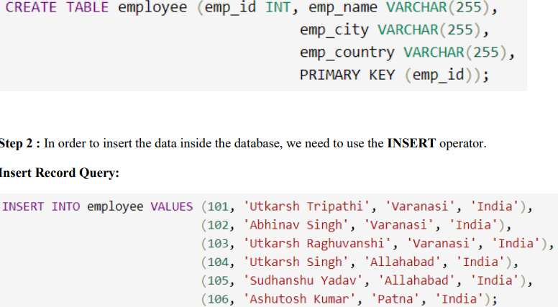

1. AND Operator
Query
SELECT * FROM employee WHERE emp_city = 'Allahabad' AND emp_country = 'India';
2. IN Operator
Query
SELECT * FROM employee WHERE emp_city IN ('Allahabad', 'Patna');
3. NOT Operator
Query
SELECT * FROM employee WHERE emp_city NOT LIKE 'A%';

4. OR Operator
Query
SELECT * FROM employee WHERE emp_city = 'Varanasi' OR emp_country = 'India';
5. LIKE Operator
Query
SELECT * FROM employee WHERE emp_city LIKE 'P%';

6. BETWEEN Operator
Query
SELECT * FROM employee WHERE emp_id BETWEEN 101 AND 104;

SQL Comparison Operators
1. = (Equal to) Operator
SELECT * FROM customers WHERE age = 20;
2. != (Not equal to) Operator
SELECT * FROM customers
WHERE age != 20;
3. > (Greater than) Operator
SELECT * FROM customers WHERE age > 20;
4. !> (Not greater than) Operator
SELECT * FROM customers WHERE age !> 20;
5. < (Less than) Operator
SELECT * FROM customers WHERE age < 20;
6. !< (Not less than) Operator
SELECT * FROM customers WHERE age !< 20;
7. >= (Greater than or equal to) Operator
SELECT * FROM customers WHERE age >= 20;
8. <= (Less than or equal to) Operator
SELECT * FROM customers WHERE age <= 20;
9. <> (Not equal to) Operator
SELECT * FROM customers WHERE age <> 20;

